Unity Intergroup Presents:
18th Annual Find Abstinence Through the Big Book Webcast
Presented by our facilitator from Canada
Registration Required: $25 (make checks payable to Unity Intergroup)
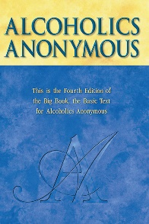
DATES: Friday, May 19th from 6:30 pm – 9:00 pm
Saturday, May 20th from 9:00 am – 5:30 pm
Sunday, May 21st from 9:00 am – 12:00 pm

Zoom meeting only: Must register with email; you will be sent Zoom meeting link and information
Contact Bob to register, or mail in form below: 763-229-6196

No one turned away! Call or text Bob with questions or if assistance is needed

Make checks payable to Unity Intergroup. Send to:

5115 Excelsior Blvd #325
St Louis Park, MN 55416

More questions? Contact Lori, Big Book Study Chair, at 715-741-2959
-------------------------------------------------------------------------------------------------------------------
Name:________________________________ Phone:_______________________
Email:___________________________________________
Number attending _______ X $25 = ___________ Amount Enclosed

