Big Book Study

Thursdays

11 am PST

Starting January 12th

These sessions will meet for approximately 1 hour, followed by 1/2 hour for member sharing.

Zoom link
Zoom Meeting ID: 833 1235 1060
Zoom Passcode: 449999
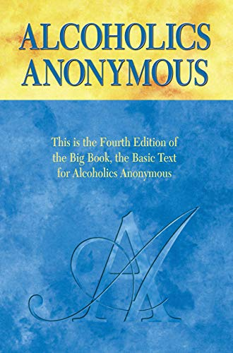
This Big Book Study is open to all.
No abstinence requirement.
No commitment needed.
No homework.
The group will last approximately 6 months.
This Big Book Study is a wonderful introduction for those new to 12-step programs. Join us for a page-by-page reading of Alcoholics Anonymous, aka The Big Book. We will read through page 103 and include explanations on the history and the meaning of these important chapters.
Each week, we will offer discussion questions for those who would like to stay and share after the 1-hour session.
Sessions will be recorded and posted to the San Diego Intergroup website – https://oasandiego.org.
The Big Book can be purchased from bookstore.oa.org or amazon.com in paper or digital format. It is also available online as a PDF.
More information:
Contact: Ann-Marie P
Phone: 619-300-6215
Email: Ann-Marie-SD2010@hotmail.com

