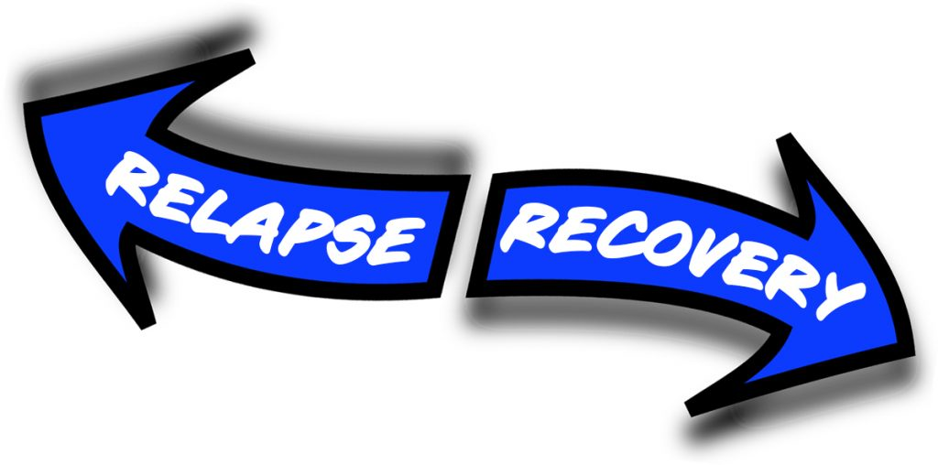

Relapse and Recovery Workshop

Sunday, January 29, 2023

1:00 P.M. – 3:00 P.M. Pacific Time

Zoom Link: https://us02web.zoom.us/j/85429749682

Zoom ID: 854 2974 9682 (no passcode)

– – – – – – – – – – – –
What are the Danger Signals of Relapse?
Relapse is not a Moral Issue – We are Powerless!
Feeling Desperate in Relapse – There is a Way Out.
Join us for this timely Workshop. All of us gain hope and joy hearing the message. The Workshop is for everyone, whatever stage of recovery or relapse your program may be. All are welcome. No registration or fees. The 7th tradition will be observed.
Questions? Please contact Elyesse at tsw@oasandiego.org
Offered by the OA San Diego Intergroup’s Twelfth Step Within Committee
